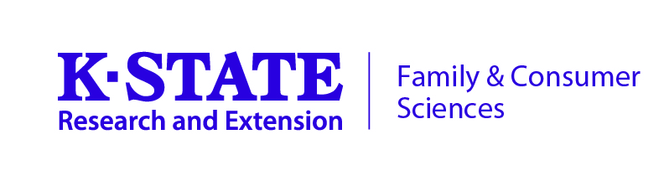
PROGRAM PROFILE

PROGRAM NAME: Supplemental Nutrition Assistance Program Education (SNAP-Ed)

DATE LAST REVISED: 2019

Grand Challenge(s): Health _X Water____ Global Food Systems____
Community Vitality____ Developing Tomorrow’s Leaders____

Program Focus Teams:
___ Adult Development and Aging ___ Community Vitality
___ Family and Child Development ___ Family Resource Management
_X Nutrition, Food Safety, Health ___ Youth Development
___ Crop Production ___ Farm Management
___ Horticulture ___ Livestock Production
___ Natural Resources

BRIEF DESCRIPTION:

SNAP-Ed is a statewide nutrition education and obesity prevention program delivered by K-State Research and Extension to Kansans with limited resources. SNAP-ED addresses a variety of factors related to increasing individuals’ household food security and overall dietary quality including healthful food selection, cooking skills, food safety, and food resource management. Additionally, SNAP-Ed works to bring about comprehensive interventions at community, organizational and institutional levels. SNAP-Ed is delivered through direct education, multi-level interventions and community and public health approaches.

EVALUATION TYPE:

Evaluation is done through pre-/post surveys which are available upon request. SNAP-Ed evaluation and reporting is done through the web-based Program and Evaluation Reporting System (PEARS)

AGENT TRAINING REQUIREMENT(S):

New to SNAP-Ed Training, SNAP-Ed October Update, other trainings as necessary.

TARGET AUDIENCE/DELIVERY METHOD(S):

Kansans receiving benefits through the Supplemental Nutrition Assistance Program (SNAP), or those eligible for SNAP (youth, adults and older adults). Direct education (using approved curricula) and Policy, System and Environmental Changes.

AVAILABILITY:

County FCS agents need to submit a Request for Proposal (RFP) by April 1 each year to receive grant funds.
Please contact program coordinator for RFP information, program materials, approved curricula and access to program website.

CONTACT PERSON(S)
Lisa Ross, Coordinator
Kansas EFNEP and SNAP-Ed
lkross@ksu.edu 785-532-2714

Gregg Hadley, Director
Kansas EFNEP and SNAP-Ed
ghadley@ksu.edu

K-State Research and Extension is an equal opportunity provider and employer. Issued in furtherance of Cooperative Extension Work, Acts of May 8 and June 30, 1914, as amended. Kansas State University, County Extension Councils, Extension Districts, and United States Department of Agriculture Cooperating, J. Ernest Minton, Interim Director. .

